# Introduction to watercolours

Watercolour is a versatile and popular painting medium known for its delicate transparency and fluidity. It is created using pigments suspended in a water-based solution, allowing the paint to be applied in washes, creating soft, luminous effects on paper. Watercolour has been used for centuries by artists for its unique properties, and ability to produce subtle gradations, vibrant colour blends, and expressive brushstrokes.

**Tools you need when working with watercolours**

* Watercolour set (paint and/or pencil)
* Appropriate paper
* Paint brush
* Mixing tray
* Water
* Pencil and eraser
* Ruler
* Kitchen paper

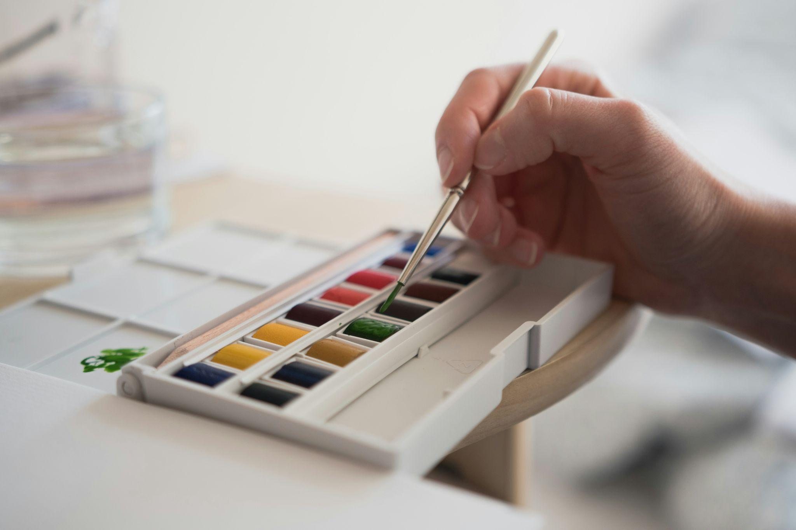

Fig. 1. Unsplash (n.d.), Watercolours

## Paper

Watercolour paper comes in different weights, commonly ranging from 190gsm (90 lb) to 300gsm (140 lb) or heavier. Heavier paper can absorb more water without warping or buckling. Watercolour paper is available in different textures:

* Hot Pressed: Smooth texture, ideal for fine details.
* Cold Pressed: Slightly textured, the most commonly used for general watercolour techniques.
* Rough: Very textured, suitable for bold, textured brushstrokes.

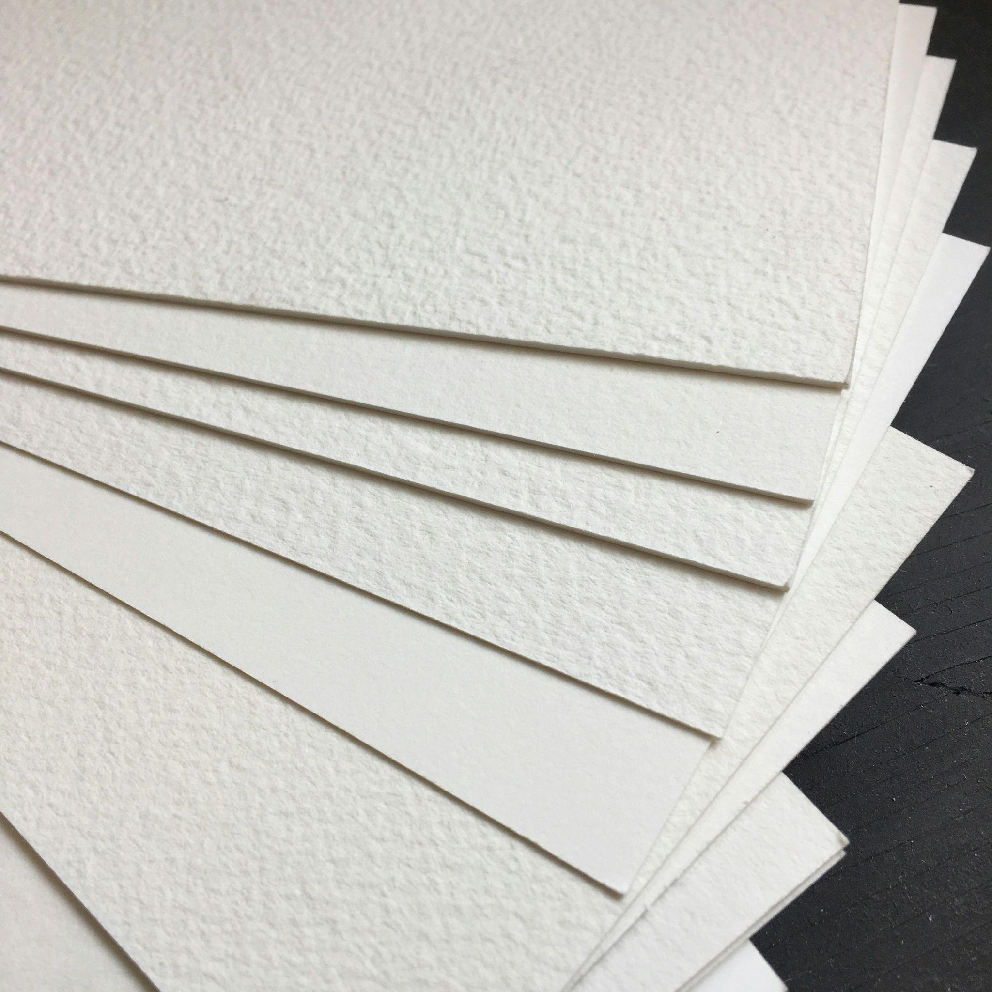

Fig. 2. Unsplash (n.d.), Promarker paper

## Brushes

Watercolour brushes are usually soft and designed to hold a lot of water. Common shapes include:

* Round Brushes: Ideal for both fine details and broader strokes.
* Flat Brushes: Perfect for creating sharp edges or laying down washes.
* Mop Brushes: Large, round brushes used for big washes or soft, loose strokes.

Natural brushes (often made from sable hair) hold more water and create softer lines, while synthetic brushes are more durable and affordable.

## 

Fig. 3. Pexels (n.d.), Paint brushes

## 

## Rendering with watercolour

### Watercolour gradient

The varying intensity of colour is created by a different amount of water mixed with each watercolour paint. In the second example a small amount of white watercolour paint has been added to lower the concentration of the blue paint.

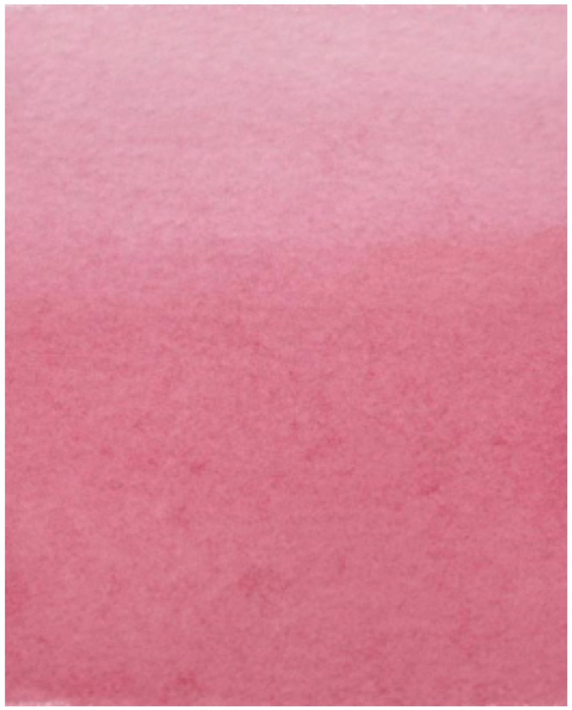

Fig. 4. Crimson Alizarin

In order to counter that result you can either blend the colour together with a cotton bud or apply a second layer of colour, as shown below:

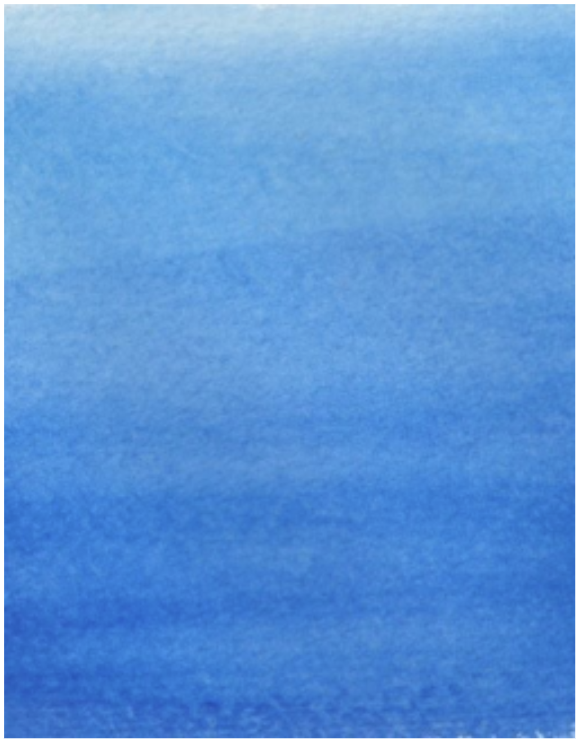

Fig. 5. Intense Blue and China White

## Mixing

Each watercolour paint is very easily mixed to create a variety of other colours to attain your preferred intensity of colour.

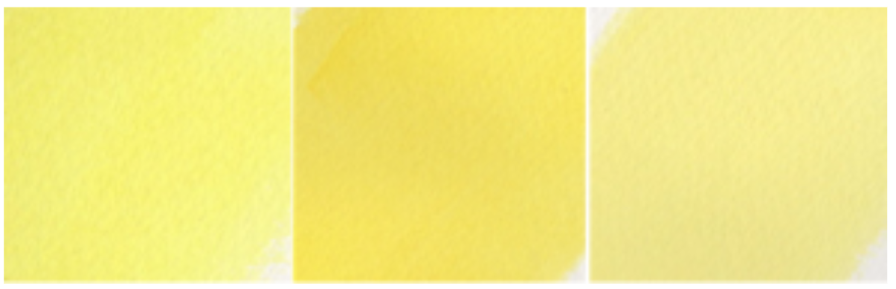

Fig. 6. Lemon Yellow (left) + Cadmium Yellow (right) = mixed yellow

## Applying watercolour in Interior Design visuals:

## **How to create timber flooring**

* Apply Yellow Ochre in a gradient from top to bottom with watercolour paint
* Next, using a ruler and watercolour pencil, draw the lines of the flooring with Brown
* Finally, use different watercolour pencils and create the details of the flooring

This example used Yellow Ochre, Orange, Terracotta and Brown to render each floorboard. Use an alternating combination of colours for each piece of timber for a more realistic effect.

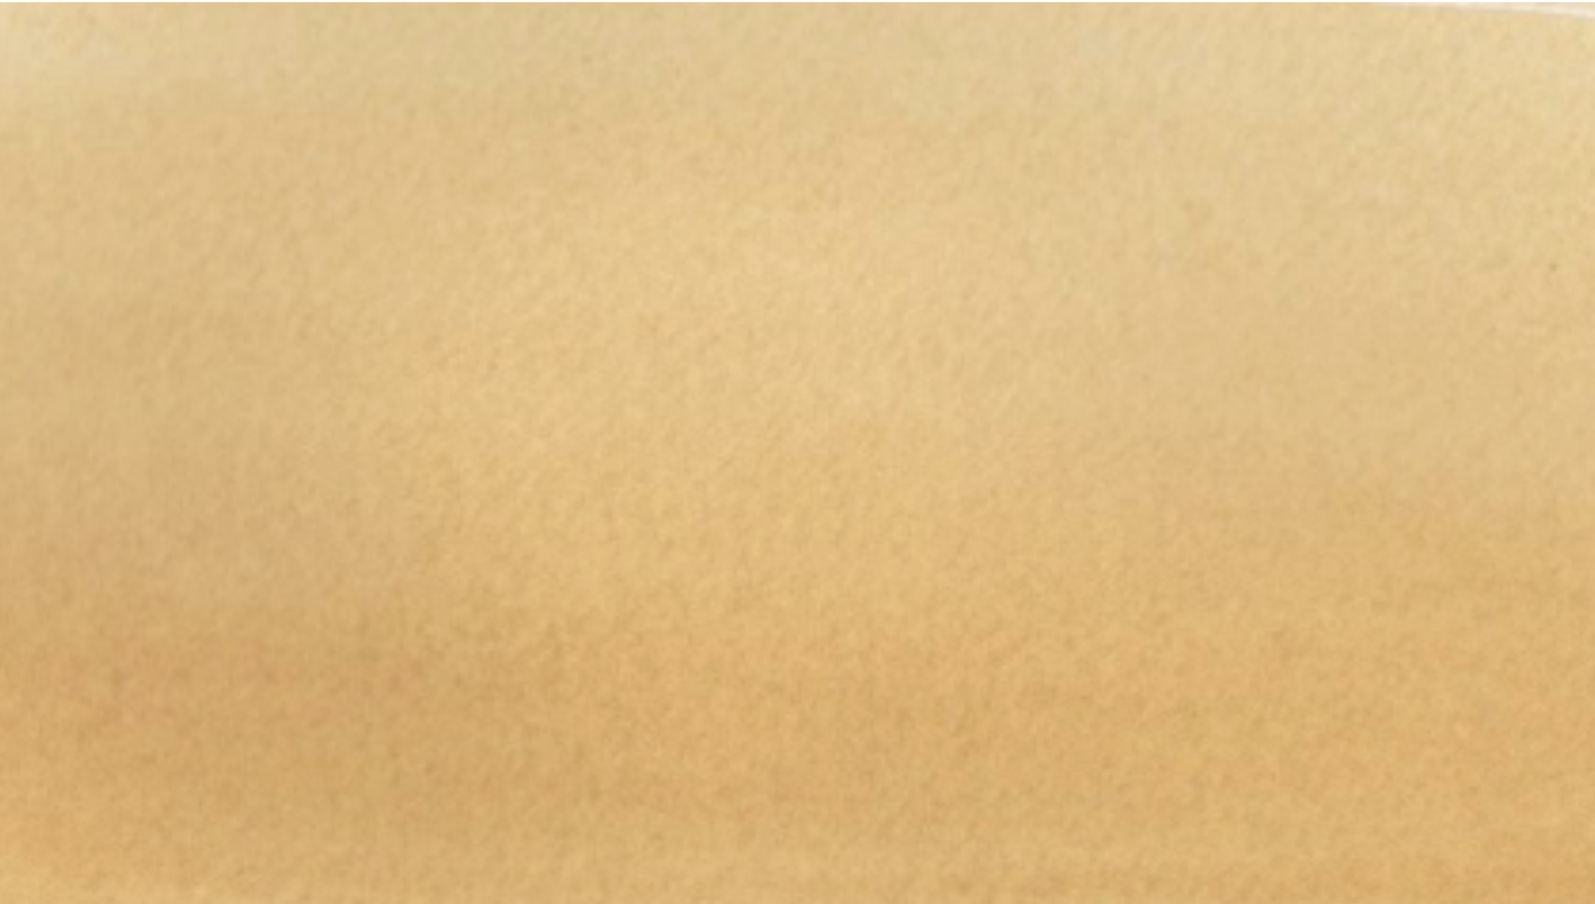

Fig. 7. Yellow Ochre applied in a gradient from top (lightest) to bottom (darkest)

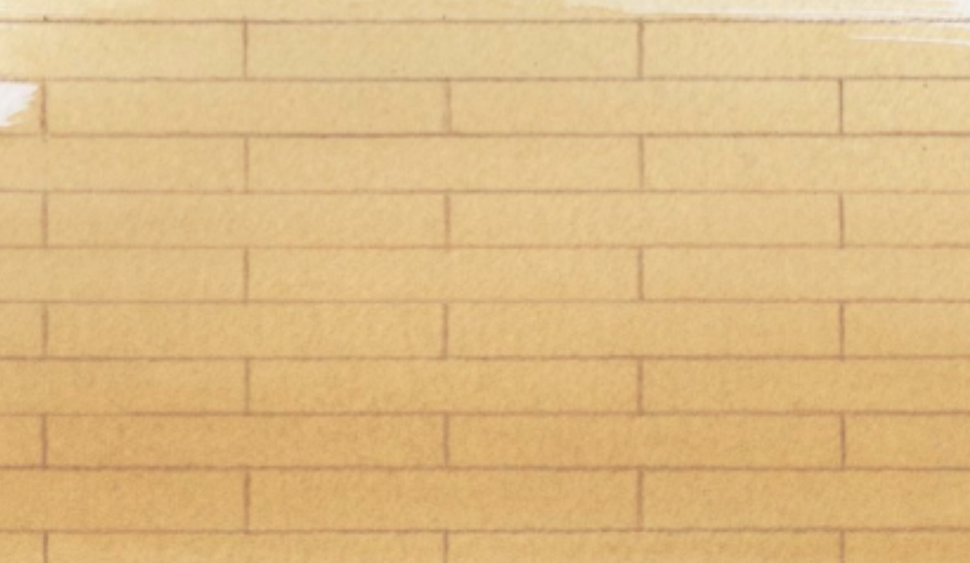

Fig. 8. Brown used to draw the outline for each floorboard with the aid of a ruler.

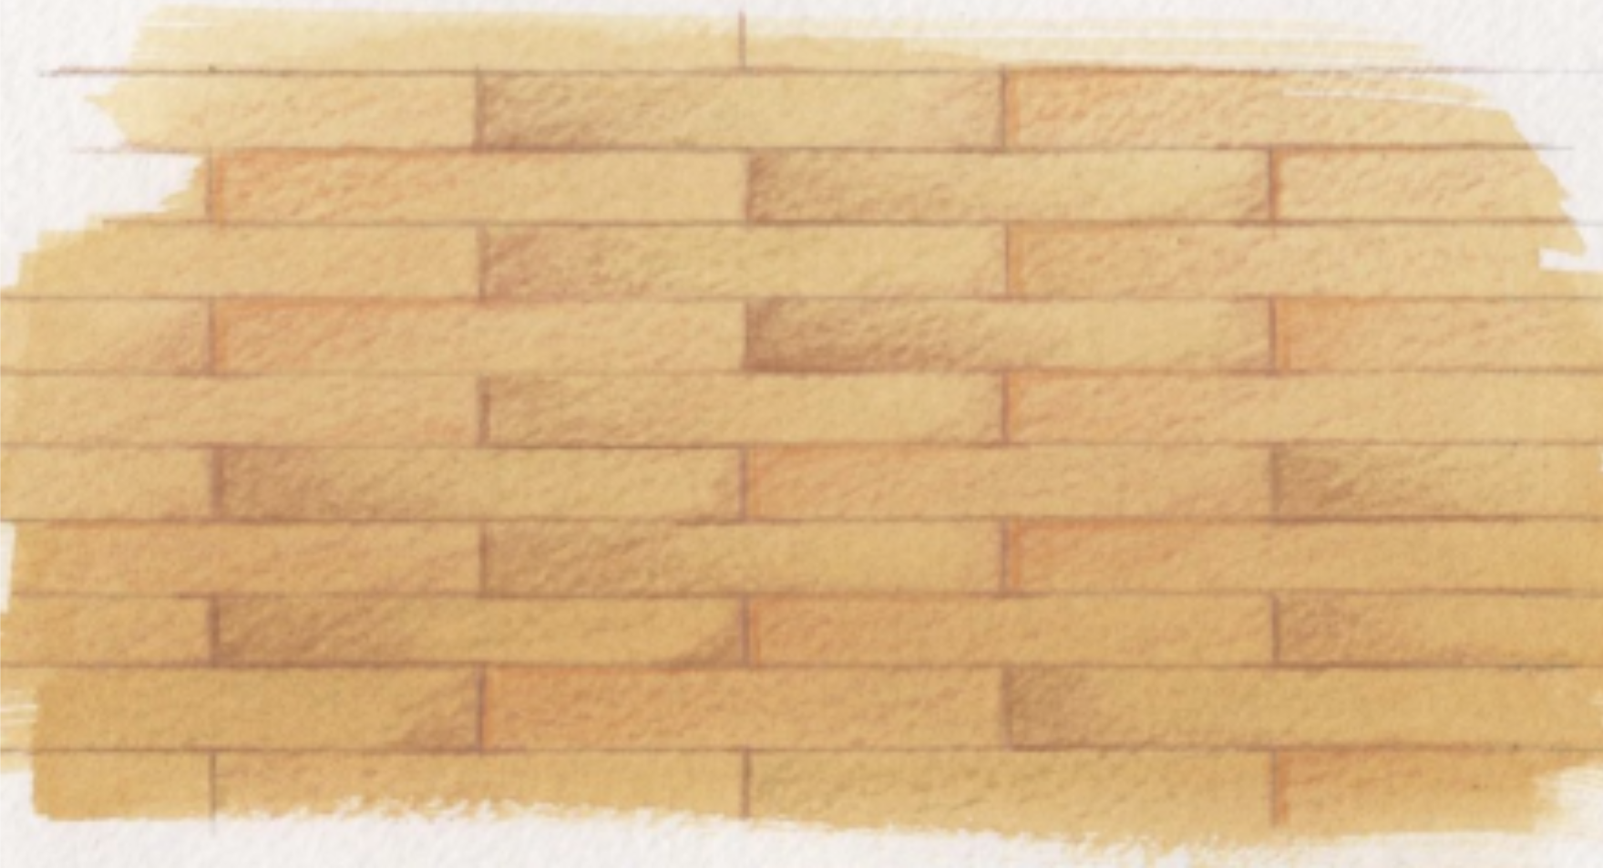

Fig. 9. Finished flooring

## **Create a brickwork wall**

* Using watercolour paint, apply Burnt Sienna in a gradient from top to bottom.
* Next, with a ruler, use white watercolour pencil to draw the outline for the brickwork.
* Finally, use watercolour pencil (in this example, Cadmium Yellow and Yellow) to render all the brickwork. Use an alternating combination of colours for each brick for a more realistic effect.

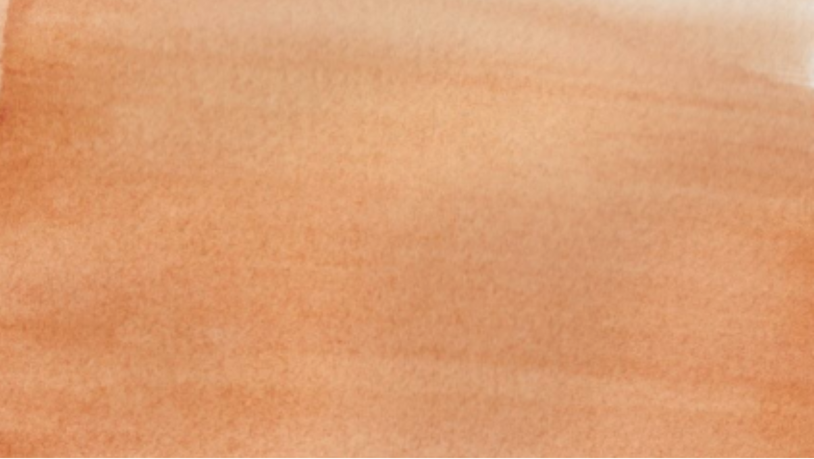

Fig. 10. Burnt Sienna applied in a gradient from top (lightest) to bottom (darkest)

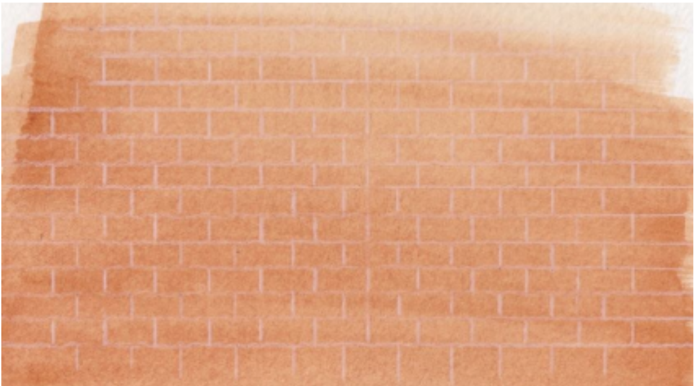

Fig. 11. Use white watercolour pencil to draw the outline for the brickwork

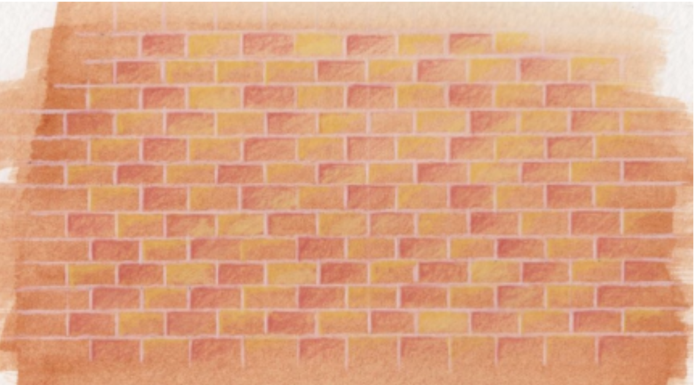

Fig. 12. Finished brickwork

## **How to create a rectangle**

#### **Step 1**

* Draw a rectangular box (preferably using a ruler to ensure the shape is drawn correctly). Note: use Sap Green watercolour paint for the rectangular box.
* Next, determine the direction of the sun and draw the outline of the shadow. Note: Yellow Ochre watercolour paint was used for the shadow in this example. The direction of the sun is indicated by the orange arrow.

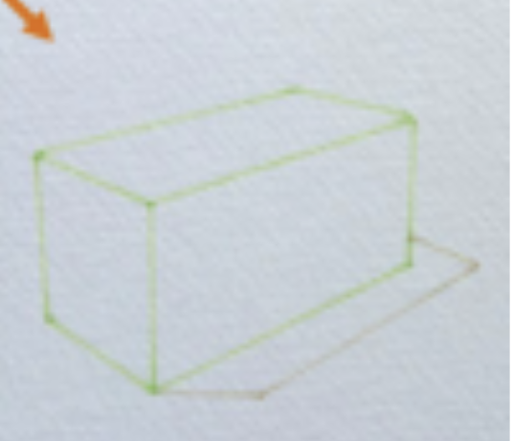

Fig. 13. Step 1

#### **Step 2**

Now you are ready to start introducing a little colour onto the rectangular box.

* First, using the Sap Green watercolour paint, apply a light wash of paint to each side of the rectangular box.
* Then, for the side of the rectangular box farthest from the light source, apply a deeper Sap Green watercolour paint. For the shadow area, use the Yellow Ochre watercolour paint and apply a light wash to the shadow cast by the rectangular box.

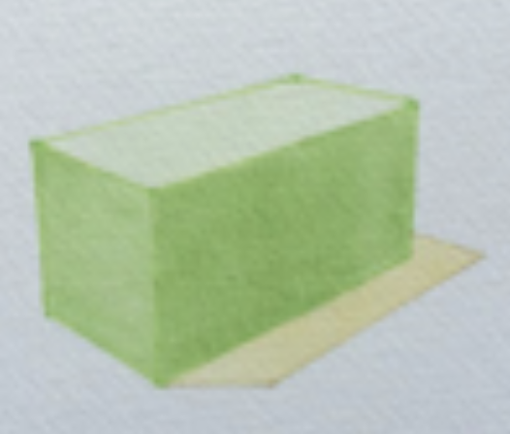

Fig. 14. Step 2

#### **Step 3**

* If more colour is required, simply add another layer of paint remembering the direction of the sun.
* To finish, redefine the outline of both the rectangular box with the Sap Green paint and the shadow area with the Yellow Ochre paint.

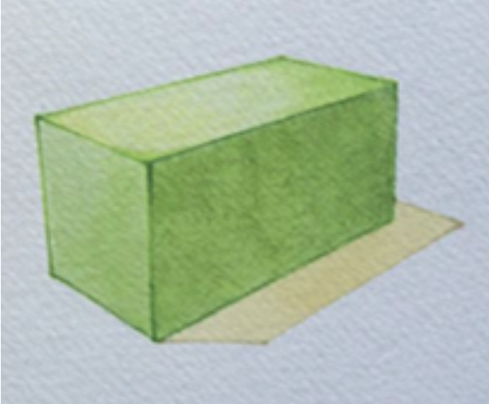

Fig. 15. Step 3

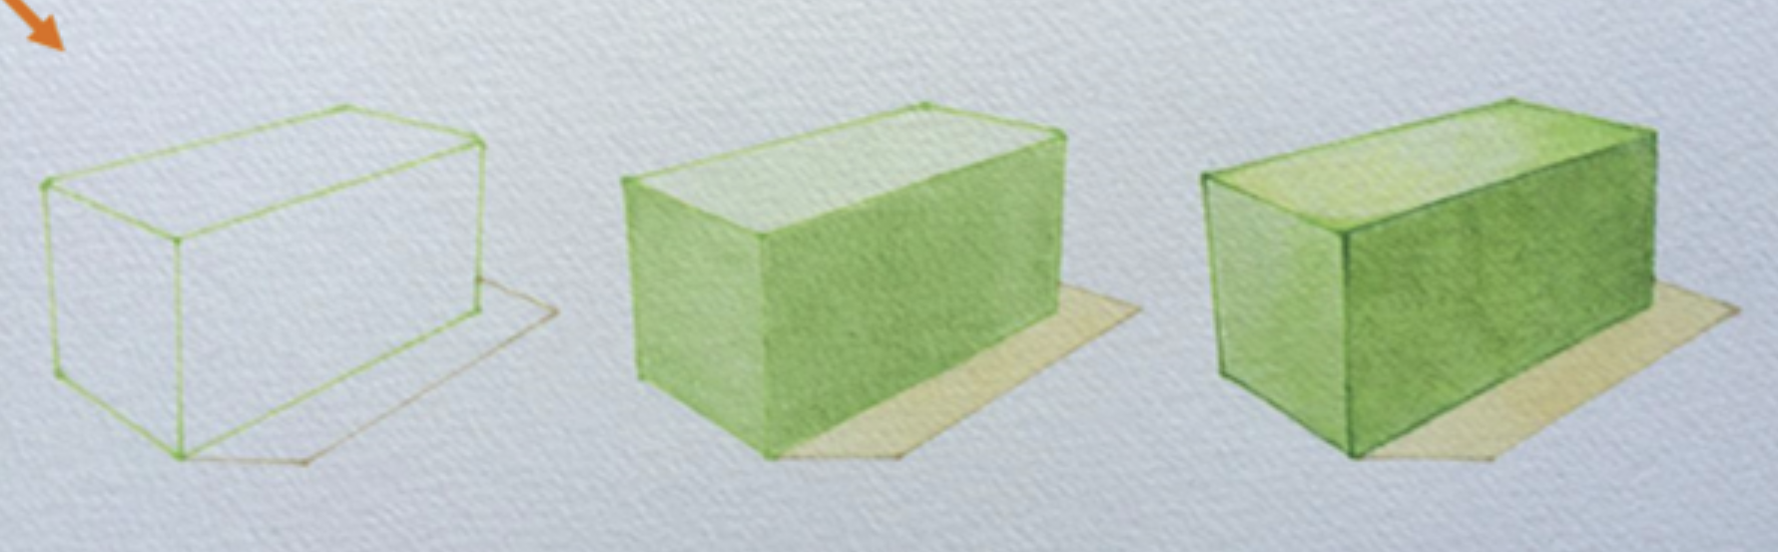

Fig. 16. Overview of how to create a rectangle

## Advantages of Watercolour

* **Transparency and light:** The transparent nature of watercolour allows light to shine through the layers of pigment, creating vibrant and luminous colours.
* **Portability:** Watercolours, especially in pan form, are easy to carry, making them an excellent choice for painting on the go, in sketchbooks, or outdoors.
* **Versatility:** Watercolour can be used for both delicate, fine details and bold, expressive washes. It’s a versatile medium suitable for various styles and subjects.
* **Quick drying time:** Watercolours dry quickly compared to oil or acrylic paints, allowing for fast progression in a painting session. This makes them ideal for artists and designers who enjoy working spontaneously or layering multiple washes in a short amount of time.

## Challenges of Watercolour

* **Difficulty in corrections:** Because watercolours are transparent, mistakes can be difficult to correct. Once a dark colour is applied, it’s challenging to lighten it without affecting the surrounding areas.
* **Control:** Watercolour has a natural tendency to flow unpredictably when mixed with water, making it harder to control than thicker mediums like oil or acrylic paint. It requires a delicate balance between precision and allowing the medium to behave organically.

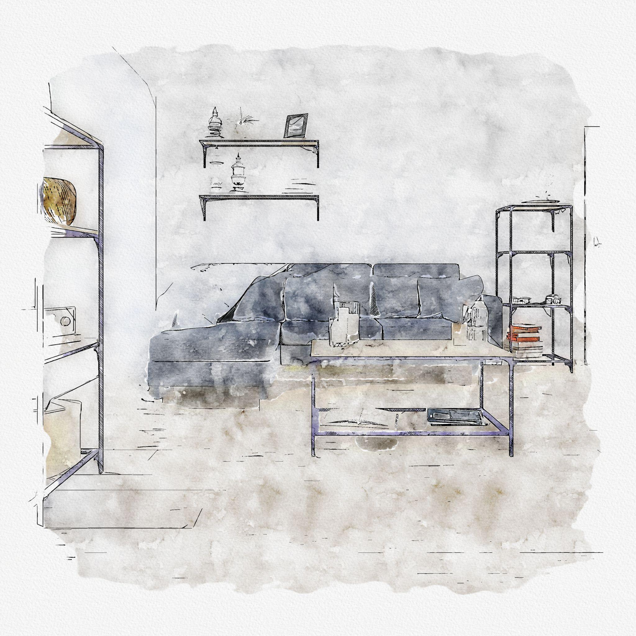

Fig. 17. Freepik (n.d.), Living room watercolour drawing

Watercolour is a timeless and expressive medium that offers endless possibilities for creativity. Its luminous transparency, versatility, and fluidity make it a favorite among artists of all levels. While it can be challenging due to its unpredictability and transparency, mastering watercolour techniques allows artists to create dynamic, atmospheric, and richly detailed paintings. Whether you're painting landscapes, portraits, or abstract compositions, watercolour offers a unique and captivating way to express artistic vision.